**BOOTSTRAP THE NET NINJA SERIES:** https://www.youtube.com/watch?v=QAgrHLtG1Yk&list=PL4cUxeGkcC9jE_cGvLLC60C_PeF_24pvv\

**1. Set up:**

a. Brand new project:

- Go here: https://getbootstrap.com/docs/4.4/getting-started/introduction/

- Copy starter template and paste it in your html file

b. Attach link to previous project:

- Go here: https://getbootstrap.com/docs/4.4/getting-started/download/

- See instruction in BootstrapCDN

c. to download the source code:

- Go here: https://getbootstrap.com/docs/4.4/getting-started/download/

- Download Compiled CSS and JS and link it in the html file

**2. Documentation:**

To look for elements, layout, components and utilities of bootstrap. Do the following steps:

- Go to this website (getbootstrap > documentation):

https://getbootstrap.com/docs/4.4/getting-started/introduction/

- For div styling > search for container

- Reboot > basic html components: table, heading, etc...

- Components > styled buttons, etc...

- Other options

**3. Appendix of important contents:**

**a. set up and some example: index.html**

**b. Bootstrap Grid and Grid Flex system:**

- Bootstrap page is divided into 12 columns

- There are 4 different screen size classes: xl < lg < md < sm

- See **bootstrapGrid.html**

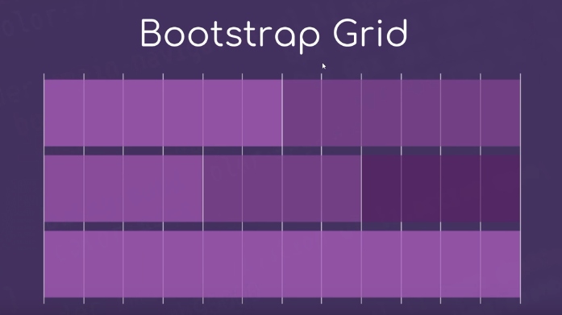

c. Other Utilities mentioned in the series:

- Jumbotron

- Text styling: search for **Typography**

- Colors: **Utilities > Colors**

- **Card**: very convenience

- Nav and NavBar

- Tooltips